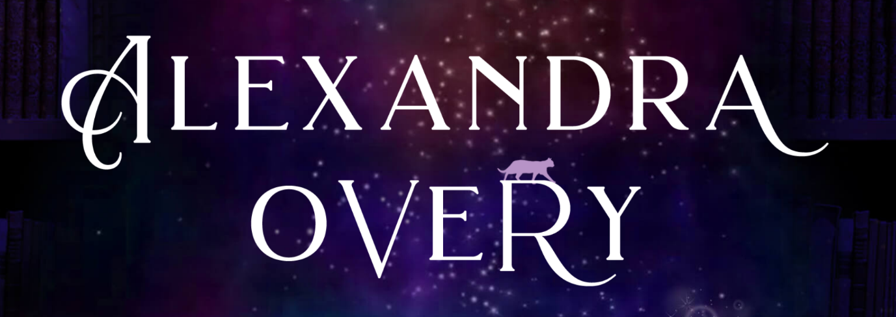
AUTHOR PRESS KIT

TABLE OF CONTENTS:
- Author Bios and Photos
- Young Adult Books
- Middle Grade Books
- Fun Facts
- Interview Discussion Ideas
- Contact Info & Links
[table of contents]

Updated June 2023

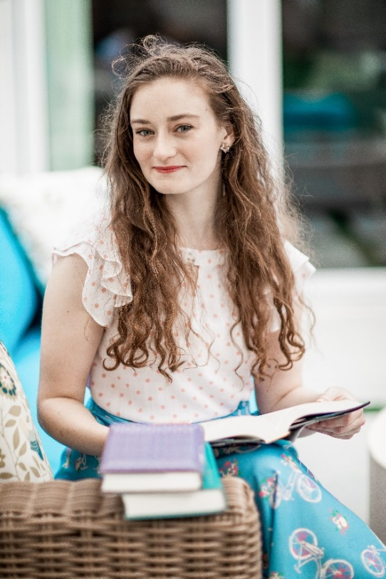
Short Bio:
Alexandra is a YA and middle grade fantasy author. She grew up in London and now lives in Los Angeles. She loves writing in all formats, from novels to screenplays to graphic novels, always centring on fierce women and morally grey characters, often with a bit of magic and murder.

Longer Bio:
Photo Credit: Sam Hardy
Alexandra is the author of the These Feathered Flames duology, as well as the middle grade fantasy series The Gingerbread Witch.
Alexandra grew up in London and moved to Los Angeles to pursue her undergraduate degree in history at UCLA. She then went on to compete her MFA in screenwriting also at UCLA, and stuck around for the weather and great ice cream. She loves writing in all formats, from novels to screenplays to graphic novels, always centring on fierce women and morally grey characters, often with a bit of magic and murder. When she’s not writing, she can be found baking, fangirling over her favourite books, or cuddling her foster kittens.
She is represented by Victoria Marini and Sydnie Thornton.
You can find Alexandra on twitter or tiktok @AlexandraOvery, on Instagram @AllyWritesAndStuff, or at www.alexandraovery.com.

Young Adult Books – for ages 13+
These Feathered Flames Duology
Out Now | Inkyard Press
Three Dark Crowns meets Wicked Saints in this queer #ownvoices fantasy debut inspired by the Russian folktale “The Firebird”.
“An engrossing fantasy tale about sisterhood and what it means to be able to fully trust another person.” - School Library Journal
“All the elements I love in young adult fantasy: lyrical prose, a unique spin on folklore, and the complicated relationship between sisters.” - Mara Rutherford, author of the Crown of Coral and Pearl duology
"A beautiful story of sisterhood, court intrigue, and ancient magic…a fantastic start to a new series!"—Kalyn Josephson, author of The Storm Crow duology
“A stunning debut as dark, lush, and captivating as the best fairy tales.” – Nina Varela, author of the Crier’s War duology

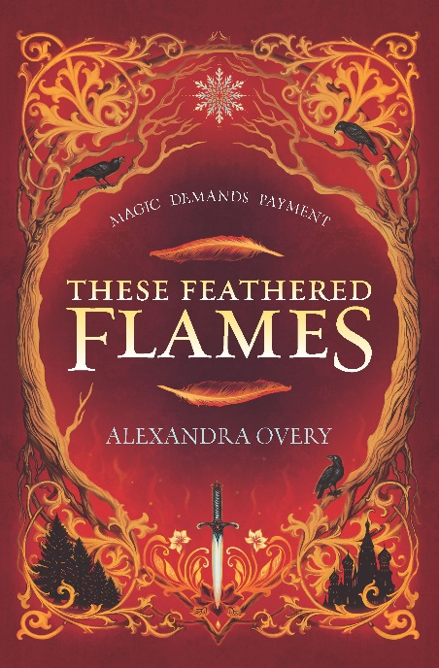
Cover Illustration: Marisa Aragón Ware
An Amazon Editors’ Best Sci-Fi and Fantasy Pick

Official Synopsis:
When twin heirs are born in Tóurin, their fates are decided at a young age. While Izaveta remained at court to learn the skills she’d need as the future queen, Asya was taken away to train with her aunt, the mysterious Firebird, who ensured magic remained balanced in the realm.
But before Asya’s training is completed, the ancient power blooms inside her, which can mean only one thing: the queen is
dead, and a new ruler must be crowned.
As the princesses come to understand everything their roles entail, they’ll discover who they can trust, who they can love—and who killed their mother.

ISBN: 1335147969
Book Two: This Cursed Crown
Out Now | Inkyard Press
“Part heist, part meditation on sacrifice, love and ambition: a
riveting coming-of -age tale.” – Kirkus Reviews

ISBN: 1335418687

Goodreads Most Anticipated YA Books of 2021

She Reads Most Anticipated Books of 2021

The Nerd Daily Most Anticipated Queer SFF of 2021

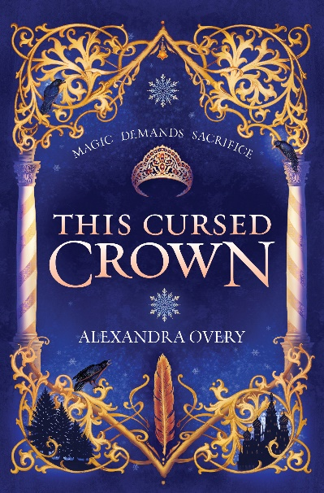

Cover Illustration: Marisa Aragón Ware
Middle Grade Books – For Ages 9+
The Gingerbread Witch
BOOK ONE
Out Now | Inkyard Press
For her eleventh birthday, Maud asked for spellcasting lessons…
“A modern reimagining that reads like a well-told fairy-tale classic.”- Kirkus
“An enticing fable that celebrates unlikely friendships, unconventional families, and an uncommon hero trying to prove she’s made of more than she appears. The Gingerbread Witch is a magical tale, brimming with heart.” – Anne Ursu, National Book Award Longlisted author of The Troubled Girls of Dragomir Academy
“What an adorable, heartwarming story. Full of baking, animal companions, and adventure, The Gingerbread Witch is the perfect mix of harrowing, magical, and lovable.” Kalyn Josephson, author of Ravenfall

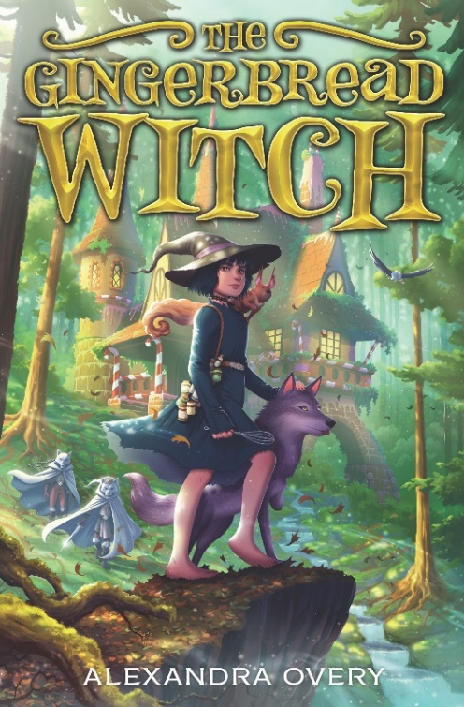
Cover Illustration: Petur Antonsson
Official Synopsis:

Maud has grown up in a house made of gingerbread, wanting nothing more than to be a witch like Mother Agatha. But just like all of Agatha’s creations—from the magical house made of sweets to the chocolate mousse squirrel, right down to the little sugar mice—Maud will turn back into gingerbread if anything ever happens to Agatha. After a terrible fight, Maud storms off only to return home to learn that Hansel and Gretel, a pair of witch hunters, have pushed Agatha into the cottage’s oven.
To save herself and the other gingerbread creations, Maud will have to go into the dangerous forest of the Shadelands to find the First Witch’s spellbook. But with witch hunters on her trail and other people interested in the book for their own means, it’ll be far from easy. Can Maud claim the book and bring back the only mother she’s ever known…or will witch hunters capture her before she can save her gingerbread family?

ISBN: 1335426868

The Unsleeping Witch
BOOK TWO
12th September 2023 | Inkyard Press
Sleeping Beauty is about to wake up…
Praise for the series:
“A modern reimagining that reads like a well-told fairy-tale classic.”- Kirkus
“An enticing fable that celebrates unlikely friendships, unconventional families, and an uncommon hero trying to prove she’s made of more than she appears. The Gingerbread Witch is a magical tale, brimming with heart.” – Anne Ursu, National Book Award Longlisted author of The Troubled Girls of Dragomir Academy
“What an adorable, heartwarming story. Full of baking, animal companions, and adventure, The Gingerbread Witch is the perfect mix of harrowing, magical, and lovable.” Kalyn Josephson, author of Ravenfall

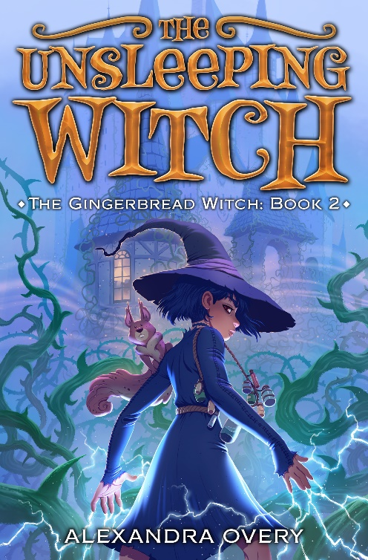
Cover Illustration: Petur Antonsson
Official Synopsis:
Maud may be made of gingerbread—plus a spark of magic—but she’s a real witch! Even if she’s still learning, and has a habit of making messes…and might have accidentally unleashed the hundred-year-old Class IV sleeping curse that envelops a princess’s bramble-covered castle. Oops.
Maud has her friends Gretel, Ludo, and Nuss the hazelnut mousse squirrel to help her fix this. But it won’t be easy to find the sleeping princess’s true love, and the curse might end up being the least of their problems…

ISBN: 1335426868

Some Fun Facts
- These Feathered Flames is Alexandra’s fourth completed book
- Her first published work was a poem in The Daily Telegraph when she was twelve titled “Opposites Attract”.
- She also works in screenwriting for film/television
- She has eleven pets: 3 dogs, 8 cats and 1 bunny!
- She’s a competitive figure skater
- She has five siblings
- She loves baking and aspires to one day be on Great British Bake Off
- She knows a worrying amount about poisons (unrelated to the point above)

Topics Alexandra can discuss in an interview
- Her experience with both novel writing and screenwriting, how they complement each other and how they diverge.
- Queer representation in fantasy and her approach to creating queer norm worlds.
- How books helped her understand her queer identity and inspired her to write about it.
- Perseverance in publishing: her path to publishing success, and the rejection along the way.
- Mental health and writing: dealing with depression and anxiety while creating.
- How her study of history inspired her to write fantasy books.

Contact Info & Links
Email: aoveryauthor@gmail.com
Website: http://www.alexandraovery.com
Publisher: https://www.harlequin.com/shop/authors/28657_alexandra-overy.html
Literary Representation: Victoria Marini and Sydnie Thornton

Social Media:
Twitter: https://twitter.com/alexandraovery
Instagram: https://www.instagram.com/allywritesandstuff/
YouTube: https://www.youtube.com/channel/UC_1mpwgCEDXYF2ndieUVSiw
Goodreads: https://www.goodreads.com/author/show/19571930.Alexandra_Overy

Purchase Alexandra’s Books:
Inkyard Press: https://www.harlequin.com/shop/books/9781335147967_these-feathered-flames.html
IndieBound: https://www.indiebound.org/book/9781335147967
Barnes & Noble: https://tinyurl.com/orderTFF
Books-A-Million: https://tinyurl.com/TFFBAM
Book Depository: https://tinyurl.com/TFFonBD
Amazon: https://www.amazon.com/dp/1335147969?ie=UTF8&n=133140011
Audiobook: https://tinyurl.com/TFFaudible

